Lecture 5
CHEMISTRY OF CARBOHYRATES (II)
Glucose, Galactose, Fructose and Mannose
Glucose, galactose, fructose and mannose are physiologically the most important hexoses. Pentoses are important in nucleotides, nucleic acids and several coenzymes. Derivatives of trioses, tetroses, and pentoses are also formed as metabolic intermediates in some pathways of CHO metabolism (glycolysis and pentose phosphate pathway). Carboxylic acid derivatives of glucose are also important. They include D-glucuronate, L-iduronate and L-gulonate. Deoxy sugars are those in which one OH group has been replaced by H e.g deoxyribose in DNA. Amino sugars include D-glucosamine, D-galactosamine and D-mannosamine.

Physiologically important disaccharides include maltose, sucrose and Lactose. Starch and glycogen are storage polymers of glucose in plants and animals, respectively. Starch is the major source of energy in the diet. It forms an α-glucosidic chain, called a glucosan or glucan. The 2 main constituents are amylose (13-20%), which has a non-branching helical structure, and amylopectin (80-87%) which consists of branched chains composed of 24-30 glucose residues with α1→4 linkages in the chains and by α1→6 linkages at the branch points. The glycemic index of a starchy food is a measure of its digestibility, based on the extent to which it raises the blood concentration of glucose compared with an equivalent amount of glucose.

Table: Disaccharides
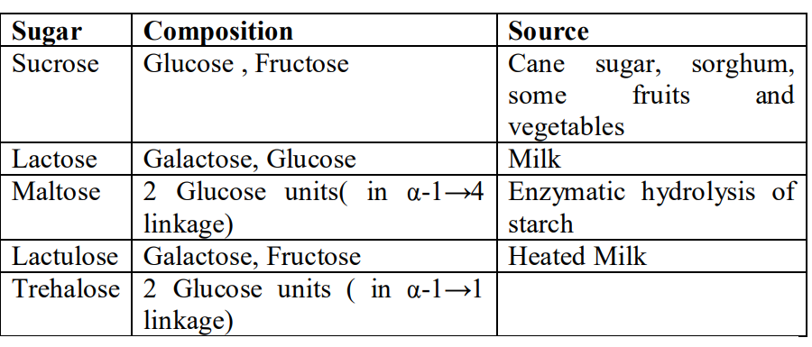

Table: Pentoses
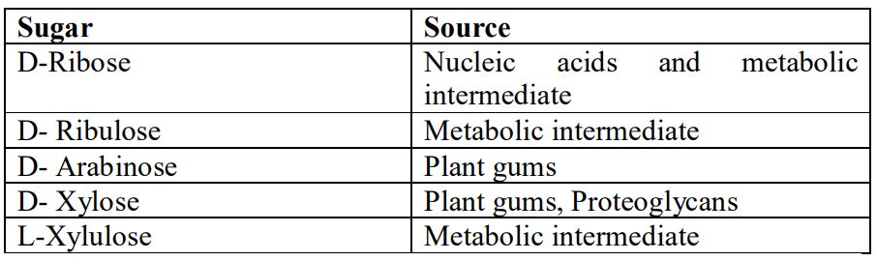

Table: Hexoses
Sugar | Source | Biochemical importance
D-Glucose | Cane sugar, Fruit  juices, starch, maltose  and Lactose | Main metabolic fuel
D-Fructose | Fruit juices, honey, Inulin | Readily metabolized via glucose
D-Galactose | Lactose | Readily metabolised to  glucose. Synthesised in  mammary gland for  synthesis of lactose
D-Mannose | Plant gums | Constituent of  glycoproteins

Some Carbohydrates of Physiological importance
Glycogen is the storage polysaccharide in animals. It is a more highly branched structure than amylopectin. Muscle glycogen granules are made of up to 60,000 glucose residues. Inulin is a polysaccharide of fructose while dextrins are intermediates in the hydrolysis of starch.
Cellulose is the chief constituent of plant cell walls. It is insoluble and consists of glucopyranose units linked by β 1→4 bonds to form long, straight chains strengthened by cross-linking H bonds. Mammals lack any enzyme that hydrolyzes the β 1→4 bonds, and so cannot digest cellulose. It is an important source of bulk in the diet, and the major component of dietary fibre.
Chitin is a structural polysaccharide in the exoskeleton of crustaceans and insects and also in mushrooms.
Glycosaminoglycans are complex CHOs containing amino sugars and uronic acids. They may be attached to a protein molecule to form a proteoglycan. Proteoglycans provide the ground or packing substance of connective tissue. Examples include hyaluronic acid, chondroitin sulphate and heparin. Glycoproteins (mucoproteins) are proteins containing branched or unbranched oligosacc chains. They occur in cell membranes and include serum albumin. Approximately 5% of the weight of cell membranes is CHO in glycoproteins and glycolipids.

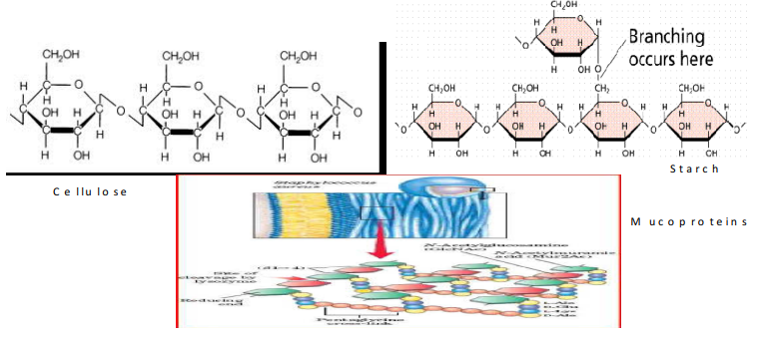
Figure 20: Structures of cellulose, Starch and Mucoproteins.

Some Reactions of Carbohydrates
1. Esterification: Monosaccharides have alcoholic groups which can participate in esterification reactions with carboxylic groups from other compounds.
2. Oxidation: Oxidation of monosaccharides with an oxidizing agent such as hypobromous acid lead to the oxidation of the aldehyde group to carbonyl group to produce either aldonic, uronic or sacharic acid.
3. Reduction: Reduction is the chemist’s term for electron gain. A molecule that gains an electron is thus “reduced”. A molecule that donates electrons is called “reducing agent”. A sugar that donates electrons is called a “reducing sugar”. The electron is donated by the carbonyl group. Reaction of monosaccharides (glucose, mannose, and fructose) with reducing agents such as sodium amalgam Na(Hg) reduces the aldehyde or keto group to produce the corresponding alcohol.
4. Dehydration: When treated with concentrated H₂SO₄ monosaccharides undergo dehydration with elimination of three water molecules. Six carbon sugars give hydroxymethyl furfurals while five carbon sugars give furfurals.

